**OR: Observing Barnard's Galaxy from Lassen 8/12/10**

One of my favorite late summer targets is Barnard's galaxy (NGC 6822) in Sagittarius. This Local Group dwarf played a pivotal role in the history of astronomy as it was the first galaxy in which Edwin Hubble identified Cepheid variable stars, which clearly established this system was extragalactic.  
  
Visually, this is a classic, large low surface brightness object – difficult or impossible in light-polluted skies, but readily visible in small apertures in a dark sky. The galaxy was discovered by E.E. Barnard using just a 5" refractor, but it really doesn't even take this aperture to view the galaxy under excellent conditions -- I've glimpsed it with 15x50 IS binoculars from a 7200' site from the Sierra Buttes.   In fact, in Hubble's 1925 paper on Barnard's Galaxy titled "NGC 6822, a remote stellar system", he made the comment "NGC 6822 is fairly conspicuous in a short 4-inch finder with a low-power eyepiece, but is barely discernible at the primary focus of the 100-inch. The latter, however, shows the bright details which are invisible in the finder."  
  
As far as these "details", Hubble recorded ten non-stellar objects in NGC 6822 that were measured on a 3.5 hour exposure with the 100-inch reflector. Later studies revealed his list included several giant HII regions as well as a couple of clusters. I took a look at a few of these objects last week while observing at Lassen's Bumpass Hell parking lot (elevation 8170') with my 18-inch Starmaster along with Mark Wagner, Richard Navarette, Ray Cash, Ken Archuleta and Mina Reyes.  
  
On the north end of the galaxy are Hubble V and X, two relatively high surface brightness HII "knots" that may be visible even when the galaxy is not seen.

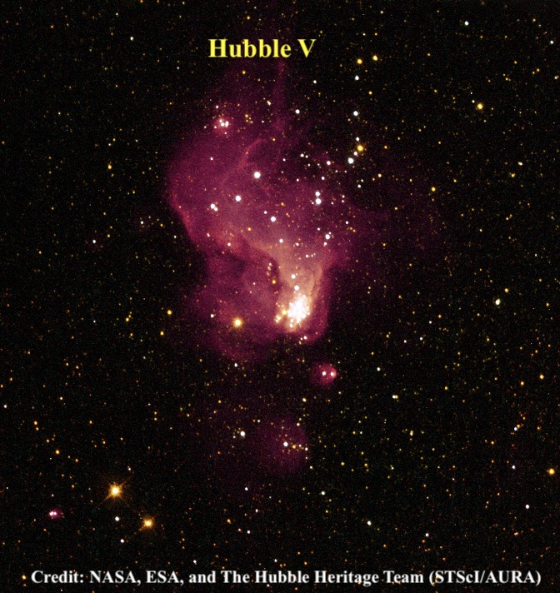  
  
Hubble X (also known as IC 1308) was easily picked up unfiltered at 225x and stood out fairly well at 285x as a 25" irregularly round knot. This HII region is located on the north side of the galaxy, 1.7' NW of a mag 12/14 pair at ~8" separation. Hubble V is slightly brighter and is situated just 3' west. It was picked up unfiltered at 175x, though to add contrast a UHC filter will work on both of these HII regions. I felt the best view was unfiltered at 225x and 285x. Hubble V has a higher surface brightness than Hubble X, though it may be slightly smaller at ~20" diameter and it forms a "pair" with a 12.5-magnitude star 1' SE. A more challenging object is Hubble III, a giant ring or shell at the NW side of the galaxy, which was barely visible.  
  
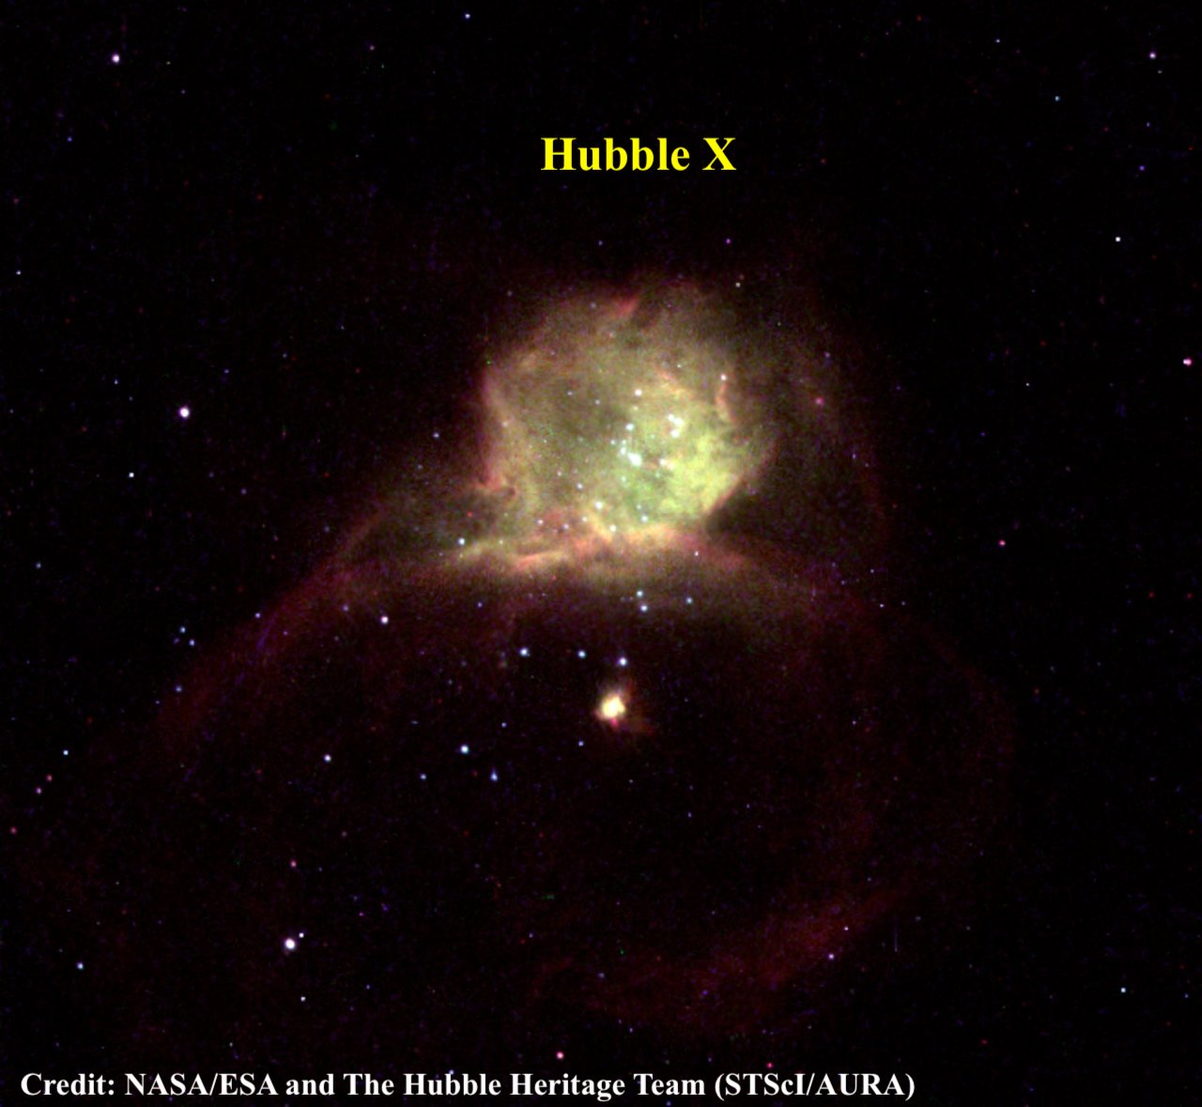

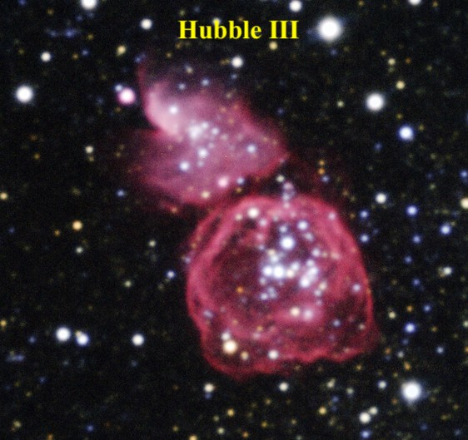

Hubble VII is the oldest and brightest globular cluster within Barnard's galaxy. I've tried for this globular a few times previously without a convincing sighting and I've never read any online visual observations of this object. A high resolution image is necessary to pinpoint the location in the center of the galaxy as a number of very faint Milky Way stars are superimposed on the face of Barnard's galaxy including a 15th-16th magnitude star just 30" WSW. In addition, a fainter star is very close to the SSE edge of the globular. But under superb conditions at Lassen (see Mark Wagner's post "Observing Report: Friendly Skies"), the globular was visible at 285x about 1/2 the time as an extremely faint and small glow, ~10" diameter. I couldn't resolve the adjacent star on the SSE edge, but the appearance was definitely non-stellar. I also viewed this challenging object at 393x and it appeared roughly similar in terms of visibility.

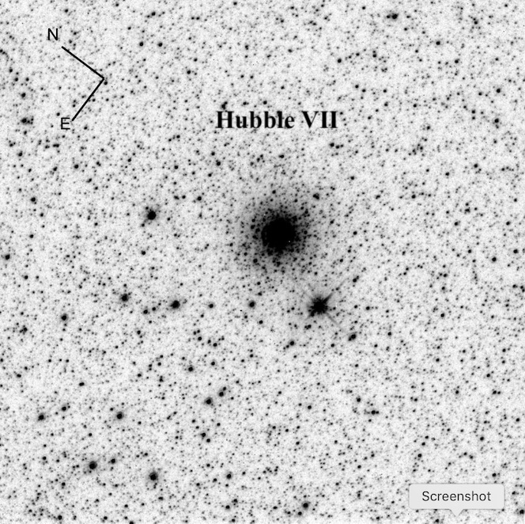

Here are the positions of these objects and Hubble even provided a finder chart in his seminal paper at [http://cdsads.u-strasbg.fr/full/1925ApJ....62..409H](http://cdsads.u-strasbg.fr/full/1925ApJ....62..409H" \t "_blank)  
  
19 44 34.4 -14 42 20 Hubble III  
19 44 52.2 -14 43 09 Hubble V   
19 44 55.8 -14 48 56 Hubble VII   
19 45 05.3 -14 43 16 Hubble X   
  
More info on these and other objects in Barnard's Galaxy check out Rich Jakiel's article on Adventures in Deep Space:  
<https://adventuresindeepspace.com/barnard.htm>